**P1- Describe the hardware and software used to create and edit graphic images**

**Introduction**

In this assignment, I will be addressing the hardware and software uses to create and edit graphic images. They are many and I am going to be talking about the following:

* ***Hardware****:* graphics card features; internal memory e.g. cache, RAM; processors; other hardware e.g. digital camera drivers and card; file storage e.g. CD ROM, hard drive, flash cards, USB storage devices; input devices e.g. graphics tablet, mouse, digital camera, scanner
* ***Software*:** vector based e.g. CorelDraw; bitmap e.g. Paintshop Pro, Paint; photo manipulation e.g. Photoshop; others e.g. image viewers, photo galleries, file conversion

**Hardware**

**Graphics card and features**

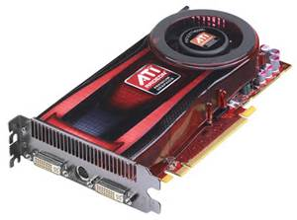Graphics card is card that is inserted on the motherboard where it helps to process the design. The better the graphics card, the better the graphics. Graphics card doesn’t come in cheap. The better the graphics card, the higher the price. Some types of Graphics card is AMD and NVidia. Especially for gamers, it plays an important role. All graphic cards have memories such as 128MB, 256MB and 512MB. The more MB you have, the faster it will run. The price of graphic cards could vary. It depends on it. The best is expensive, around £500.

[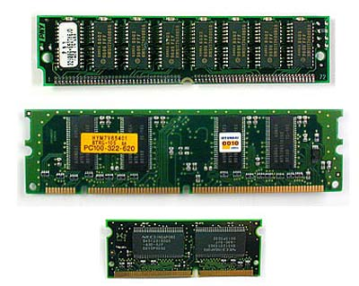](http://www.google.co.uk/url?sa=i&rct=j&q=ram%20rom%20cache%20memory&source=images&cd=&cad=rja&docid=9cIEF6-cd20oJM&tbnid=1KB0gdRVoX7UCM:&ved=0CAUQjRw&url=http://www.howstuffworks.com/computer-memory-pictures16.htm&ei=7HQ5Usz-EKXA7AbOs4HABw&psig=AFQjCNE_O7VXHYUOjBaCKxr0YnLFT4ODgw&ust=1379583594275891)**Internal Memory**

**RAM** is also known as random access memory is used to store data. This is inserted on the motherboard which it is located there. When the computer is switched on, the files that are stored on the RAM automatically be operating as long as the computer is running. All the documents that you create is stored on the RAM. **ROM** (Read only memory) are data that is stored on this memory, but cannot be changed. This is much different to RAM. ROM is when data is stored permanently on to this chip. As well as storing data, this gives out instructions. **Cache** enhances and speeds up the internal storage data and given instructions without knowing. This doesn’t use RAM, this uses internal storage.

**Processors**

[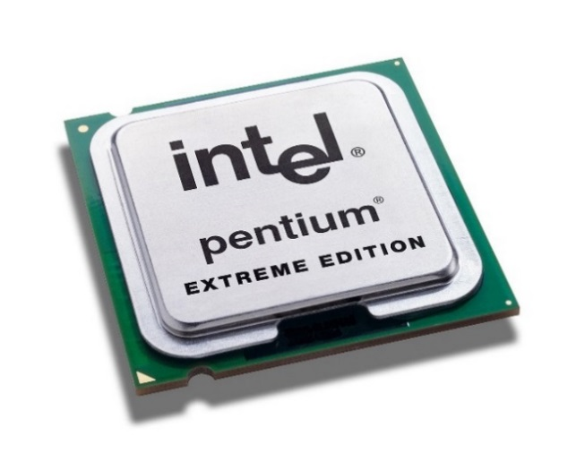](http://www.google.co.uk/url?sa=i&rct=j&q=pROCESSOR&source=images&cd=&cad=rja&docid=Wqo2CsMR9WJb0M&tbnid=wUqVsUbmOw8oEM:&ved=0CAUQjRw&url=http://www.intel.com/pressroom/kits/pentiumee/&ei=R3M5UuC7B5CS7Abes4CoCQ&bvm=bv.52288139,d.ZGU&psig=AFQjCNHo1S5OHxIMpCoXCgyrEZYnu9c4CA&ust=1379583159950691)A processor is a microchip imbedded into the CPU’s hard drive that manages all the programmes. It’s known as the, “brains of the computer”. The processor holds instructions which is given to the programmers. They are different types of processors; INTEL and AMD. For example, INTEL has different types such as; Intel i3, i5, i7. Intel i7 has 4 cores. The speed of this is 3.5GHz. The cache is 6MB. Obviously, each of the Intel processors named, they have different speed and cores. They have an electrical path that allows communicate between other components.

**Other Hardware**

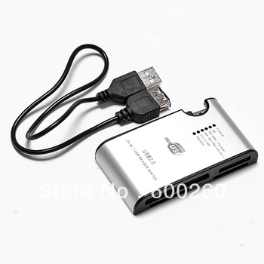**Digital Camera Drivers and Card**

Digital camera drivers is a device that enables communication along with a computer and this device. Modern digital camera drivers use USB cables to connect the two together. Once you connect the two together, you can transfer, print, and edit the photo on the computer using specific programmes. As the image demonstrates, you insert both cards into the USB port in the computer.

**File storage**

* **CD ROM**

CD ROM is a type of file storage where you can store data such as files, documents, images, music, videos etc. The size of it varies. It is important as it identifies how much data you can store on the specific storage. Data stored on CD ROM varies from 650MB to 900MB. It depends on the thickness if the thickness is greater, the megabyte increases. These can be used as a back-up. Therefore, if any files are lost, you can restore them by using this CD.

* **Hard drive**

Hardware Disk Drive (HDD) is installed within the system unit on the computer motherboard. As any other file storage, it stores files on it. It can store gigabyte, megabyte and terabyte. As the image shows below, each of the following increase by storage. Therefore, if you have 1TB, you can store as many files as you want until it finishes.

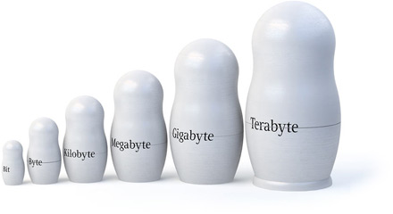

**Input Device**

**Scanner**

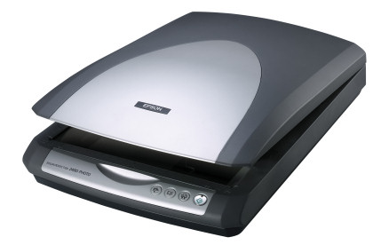Scanner is sort of fittings used to output hard duplicates, for example, pictures or content, after it is then moved into the workstation through USB link or in some cases even remotely. After the picture being moved into the machine it can then be altered, for example, uprooting a few points of interest or including a few subtle elements, and afterward be printed if the client needs it in a hard duplicate. At the point when the hard duplicate is, no doubt examined the client can pick how the picture ought to be seen either dark & white, colour, negative, and so forth.

**Software**

Figure 1.1

**Vector Graphics**

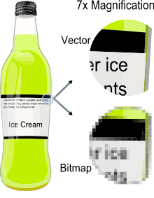Vector is a graphic computer image that it is a scale of quality when it has been enlarged. When it is enlarged, users are focused on the vectors of the image e.g. paths, strokes. It does not lose quality when the image has been enlarged. Referring to the figure 1.1, it shows when you enlarge the image of the bottle. Vector images come out clear whereas Bitmap images does not become clear when it is enlarged. Comparing vector images to ‘JPEG’, ‘GIFs’ and ‘BMP’, it does not contain grid pixels, but it can be different as paths, strokes and curves.

**Bitmap graphics**

As said before, bitmap is a graphic compute image that uses pixels (tiny blocks), because when the image is enlarged, unlike vector graphics, it loses quality. Bitmap graphics can be used on where pixel display is common e.g. CCTV cameras. It is not HD quality, but has pixels like bitmap to be used to create a bitmap display. Referring to figure 1.1, it demonstrates how bitmap image looks like. When it is enlarged, it shows us the pixels. Unlike bitmap, vector images are clear.

**Photo manipulation software (Adobe Photoshop)**

Adobe Photoshop is a graphic software where images are used to edit images as far as possible. Photoshop has many features to allow users to think that it may not even be Photoshop; it is one of the leading graphic software. Some of the tools that may be used include:

* 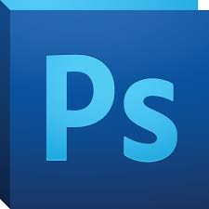Colour pick
* Lasso Select Tools
* Paint Bucket

**Image Viewers**

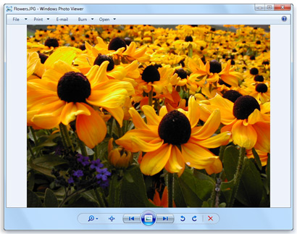A picture viewer is a provision which permits the client to view different sorts of picture organizations. 'Picture viewer' typically decreases the record picture relying upon its properties, for example, show determination, colour, profundity, and shade profile. A few clients may utilize programming, for example, 'Photoshop', 'GIMP', however picture viewer not just gives the client a perspective to look the picture, additionally an alternative to alter the picture in an essential manner. Giving a fundamental altering alternative to the client is a great way in light of the fact that the client may not know essential when it comes altering realistic pictures. Most picture viewer programming's does not give a classification of client's picture thusly the client need to make without any preparation. These classes might be similar to 'label', 'organizer', 'collection', and so on.

**Photo Galleries**

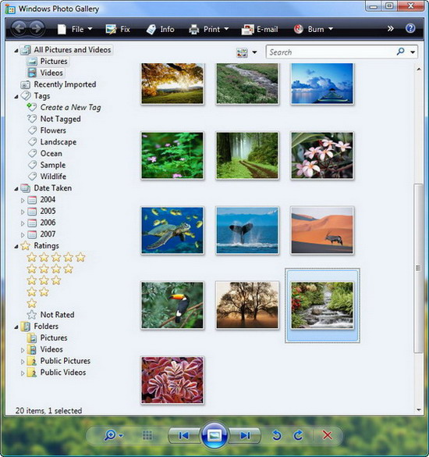Photograph exhibition is a kind of programming that permits the client to oversee, view, alter, and offer photographs. The greater part of the pictures in the record 'My pictures' are naturally transported in into the photo galleries programming which then the client can see the pictures in its classification. Photograph exhibition permits clients to impart their photographs to their family and companions by clicking on the offer logos. Furthermore, photo galleries allows clients to upload these images on SkyDrive, Facebook and other social networking sites.